Incident Response Report

Summary
- Severity: High
- Priority: P1
- Asset(s) Affected: Kingslanding (192.168.224.161)
- Incident Owner: Sebastian Salas
- Contact Information: sebasala@ensign.edu
- Incident Start Time: 2024-12-16T21:51:21Z
- Incident Close Time: Under Investigation

Incident Timeline
- 2024-12-16 21:51:21 UTC:
A network logon event is detected on kingslanding.sevenkingdoms.local using an ANONYMOUS LOGON account via NTLM V1. This uses a 128-bit session key, raising concerns about potential security risks with the outdated protocol.
- 2024-12-16 21:51:37 UTC:
The Wazuh manager logs Event ID 4624, confirming a successful network logon (Type 3) from source IP 10.0.196.19.
Severity assessed as High due to NTLM V1 usage and anonymous logon.
- 2024-12-16 21:55:00 UTC:
Initial analysis suggests the logon may be from internal system activity or an external probe. This could be a Pass-the-Hash attempt or SMB enumeration.
- 2024-12-16 22:00:00 UTC:
Analysts perform a network scan to check for unauthorized SMB traffic from IP 10.0.196.19. Internal teams are involved to verify the legitimacy of the logon.

Triage and Analysis
- Incident Description:
A network logon event was detected on kingslanding.sevenkingdoms.local at 21:51 UTC on December 16, 2024. The logon used NTLM V1 with an ANONYMOUS LOGON account, which is a security concern due to the outdated protocol. The logon was made from the IP address 10.0.196.19.

- Detection and Response:
- The logon event triggered a Wazuh alert with Event ID 4624, signaling a successful network logon with NTLM V1 and an anonymous account.
- Immediate actions:
  - Analysts reviewed the logs and assessed the use of NTLM V1.
  - A network scan was launched to identify if the logon was from an internal system or an external attacker.
  - Internal team validation to check for legitimate access.

- Indicators of Compromise (IOCs):
- IP Address: 10.0.196.19
- User Account: NT AUTHORITY\ANONYMOUS LOGON
- Protocol: NTLM V1 (vulnerable authentication protocol)
- Logon Type: 3 (Network)

- Scope and Impact:
- Scope: Possible external or internal misconfiguration.
- Impact: Increased risk of Pass-the-Hash or SMB enumeration attacks due to the use of NTLM V1 and anonymous access.

- Supporting Evidence:
  - Logs show the suspicious event and account usage.
  - Wazuh alert identified the logon and raised concern due to NTLM V1 use and anonymous credentials.
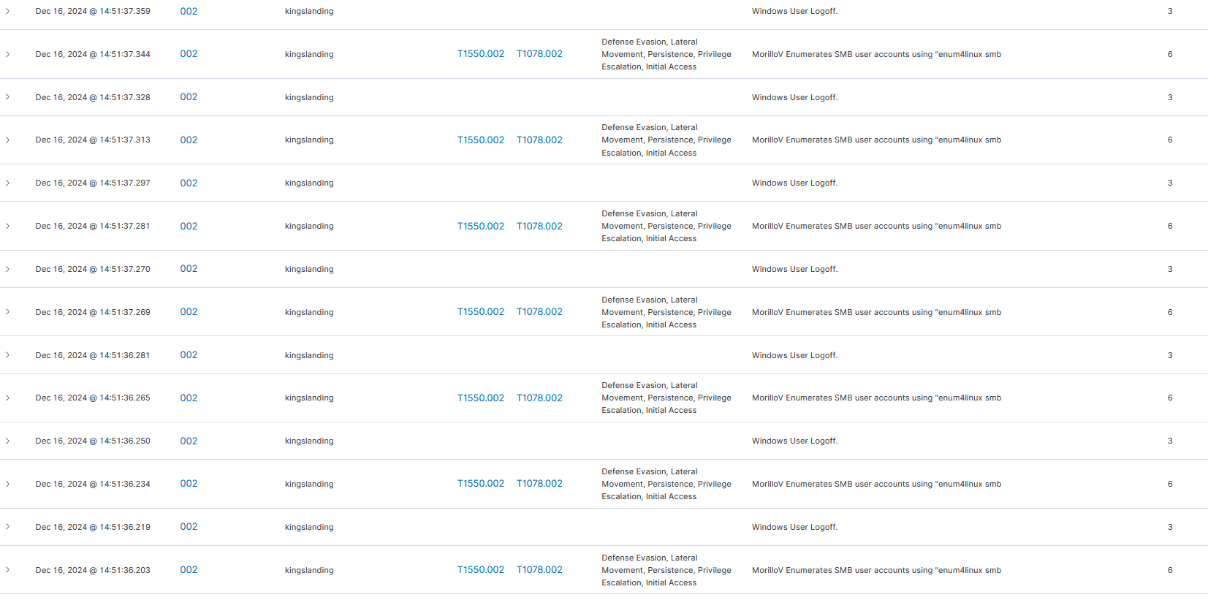

Containment and Neutralization (Short-term/Triage)
- Isolate-Affected Systems:
  - Disconnect kingslanding.sevenkingdoms.local from the network.
  - Block the IP 10.0.196.19 in the firewall.
- Immediate Actions:
  - Disable the ANONYMOUS LOGON account.
  - Restrict or disable NTLM V1 authentication.
  - Reset passwords for important accounts.
- Temporary Measures:
  - Monitor network and authentication logs for further issues.
  - Block SMB and NTLM traffic if needed.
These actions will limit further damage and allow for further investigation.

Recovery and Vulnerability Remediation
- Recovery Steps:
  - Restore kingslanding.sevenkingdoms.local from a clean backup if compromised.
  - Reconnect affected systems to the network after thorough verification.
  - Re-enable necessary accounts after resetting credentials.
- Vulnerability Assessments and Patching:
  - Conduct a full vulnerability scan to identify potential weak spots.
  - Apply patches for any outdated software, specifically addressing NTLM V1.
  - Enforce stronger authentication methods, like NTLM V2 or Kerberos.
- Communication with Stakeholders:
  - Notify internal teams (e.g., IT, security) via email or communication platform.
  - Inform leadership about the severity and actions taken through a report or call.
  - Update stakeholders on the ongoing recovery process and any necessary actions.

Hardening and Detection Improvements (Lessons Learned, Long-term Response)
Detection Improvements:
Custom Rules for Reconnaissance and Enumeration:
- Detect tools like nmap and suspicious SMB scanning with these custom rules:
